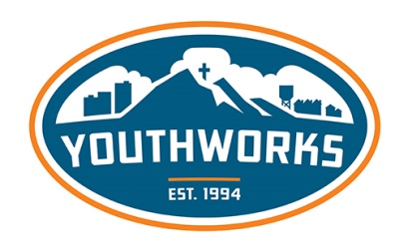
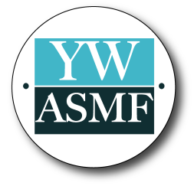
YOUTHWORKS ALUMNI
STAFF MISSION FUND
PROGRAM GUIDELINES & APPLICATION FORM
Program Guidelines:
YouthWorks Alumni Staff Mission Fund (YWASMF) exists to support YouthWorks alumni summer staff in continuing their pursuit of mission experiences. YouthWorks alumni can receive $100—$250 for their next mission experience with a church, academic institution or nonprofit organization.
- Applications are accepted from alumni summer staff, part-time and full-time staff.
- A completed application is required to be considered, but does not guarantee financial support.
- A prayer and/or support letter should be included with the application if available, but it is not required.
- Applications must be submitted prior to the mission experience.
- Mission experiences requiring funding less than $1,000 are not eligible for a YWASMF grant.
- Checks will be made out to the mission organization or church the applicant is serving with, not the applicant.
- Alumni are eligible for only one YWASMF grant each calendar year, and can only reapply for a grant if they have served the summer preceding the request.
- There are limited funds available each quarter. When the funds have been depleted, applicants will be encouraged to apply the following quarter.
- Have additional questions about YWASMF? Contact Lindsay Crye at 612.746.6425 or Lindsay.crye@realresources.com
Funding Scale:
- Funding required >$5,000- eligible for $250 grant
- Funding required <$5,000- eligible for $100 grant*
*Mission Experiences requiring finding less than $1,000 are not eligible for a YWASMF grant.

Alumni Information
Name |  |  | Home street address
Phone number | Email address |  | City |  | State |  | Zip Code
YouthWorks History
Community | Position | Year | How did you find out about the YWASMF?
Community | Position | Year
Missions Experience Information
Location | Date{s}  mm/dd/yyyy to mm/dd/yyyy |  | Total cost |  | Date funds need to be secured  mm/dd/yyyy
Explain the purpose of this missions experience

Why have you chosen to participate in this mission experience?

Financial Information
Make check payable to |  |  | Address
Memo line on check |  |  | City | State |  | Zip Code
EIN Number of the Mission Organization or Church

Signature
I, , certify that I have reviewed and understand the YWASMF guidelines. |  |  |  |  | Date

Submit by email or mail:
lindsay.crye@realresources.com
Real Resources Foundation
Attn: YWASMF
5320 W 23rd St, #130
Minneapolis, MN 55416

